West Middle PTO Meeting

Date: December 13, 2023

7pm Library

Call to order: 7:05pm.

Attendees: Dana Lorenz, Julie Wyatt, Jeanna Gossett, Casey Pfarr, Emily Schlick, Lori Conran, and Jami Gumpel, Kate Deckelbaum, Myriam Gitt, Tamara Welliner, Lauren Deichmann

**President’s Update**:  Review and Approve November meeting minutes. Motion to approve: Jeanna Gossett. 2nd to approve: Jami Gumpel.

* Longhorn Legacy - Thank you to our Fundraising Committee for the boost in our direct giving budget with their efforts of the video and fundraising meter. Giving Tuesday took off with $3K in 24 hours. Thank you to Stephanie Stokes and Myriam Gitt for stepping up to help create the video.
* Adopt A Family- Thank you Lisa Tarter for leading this effort to ensure families in Parkway receive holiday cheer. Parkway Social Workers reached out to the PTO. Almost all the slots were filled by families. Gifts were delivered on 12-12 to Social Workers.
* Teacher Grants- A few grants were missed in the review in November and all but one were able to be voted on through our PTO board.  We have one to review as a general body (a stove for FACS) and all but one grant has been ordered.  We are waiting on specifics for the STAR Room request which was approved up to $500 for their request. 11/15/22.
* Cotillion- Julie to address as a discussion, details to come later in the meeting.

**VP of Fundraising-** Jeanna Gossett, Pamela Betz, Stephanie Stokes, Myriam Andrews

* Rock and Roll Bingo- April 1, 2023 Ballwin Golf Course. They are looking for committee chairs – advertisement for flyers – social media and decorations. The evening of the event they need help with set-up and tear-down. The recommendation was to create a Sign Up genius to distribute to the West families. Immediate need is solicit auction donations. Myriam Gitt volunteered to help with the event.
* Direct Giving- Longhorn Legacy. A huge shout out to Stephanie Stokes for creating a video for Giving Tuesday. Also, the Longhorn Legacy name was created. Of the $12K goals we are up to $6950.
* Spirit  Wear. 12-13 is the last day to order off the spirit wear store.
* Papa Johns. 2-21-23 is the next day!
* Pretzel Sales. 1-6-23 is the next sales day. Other days schedule; February 3rd. April 14th.
* Amazon Smiles/ Box Tops. The link for Amazon Smiles came out in the last PTO Newsletter. It was also discussed to add a Kendra Scott or Paperdolls shopping day before Valentines Day.

**Treasurer Report**- Emily Schlick

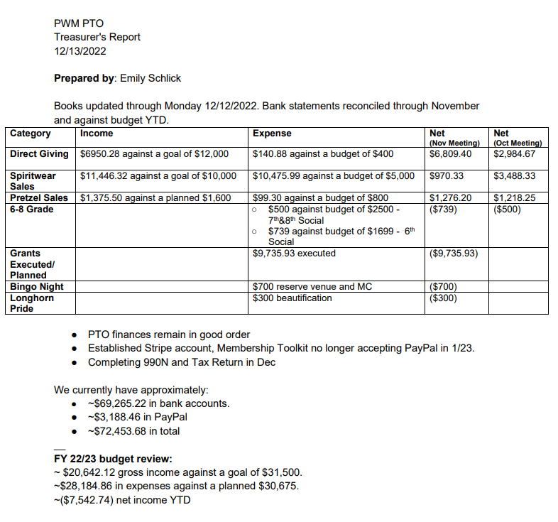

Historically we have kept $30-$35K in the bank at the end of the school year. Membership Toolkit is breaking ties with Paypal. Beginning in January 23’, you have to use Stripe.

**VP of Communications**:  Jen McCurdy

No updates - if anyone needs anything posted on the calendar or FB, just let me know! :)

**VP of Community**- Anne Branch

* Staff Appreciation- Kate Deckelbaum, Lori Conran, Angie Stevens. Thank you to the committee for the adopt a staff member. The next delivery for gifts is 12-16-23.
* Government Relations- Jennifer McGillvary.
* Cotillion- Jamie Gumpel. Her role is to set up the dates and ensure rooms are available. Once the enrollment hits 80 Cotillion has add more teachers. Cotillion is not sponsored by the PTO. There was discussion about adding limited scholarships for the 23-34’ school year. Another option is to ask Cotillion to provide scholarship for students in need. Transportation would be required by the family. Jamie is going to take the lead with her contact at Cotillion if this is a possibility for the 22-23’ school year since enrollment is still open.
* Winter Family Night- Anne Branch. January 27th from 6-8pm. Mario Kart tournament. Details are coming out in the upcoming weeks.
* 8th Grade Celebration- Mandy Kelly, Robyn Hayes, Kristen Merriman.
* Longhorn Pride/ Beautification.
* 3K Fun Run- Robyn Hayes March 11. Theme: Lucky to be a Longhorn. Location: West Middle.
* 6th grade reps- Stephanie Stoke and Myriam Andrews. 6th grade party has been rescheduled to January 20th from 3:30-5:30pm.
* 7th grade reps- Aurella Clinkscale and Angie Stevens. Approximately 500 students attended. The recommendation is consider grade level parties in 23’-24’.
* 8th grade Lori Conran and Kate Deckelbaum.

**Principal’s Report**- Dr. Kealen

* Concert season is in full swing!
* Project Parkway 3.0 is kicking off after the 1st of the year. It is an 18-month process with a ton of community input into the say with the direction of the District.
* 5th grade parent night: January 11. 6-7:30pm. PTO was present last year. He has requested PTO presence.
* Projects:

1. Bike Rack: $300. Approved to purchase.
2. Padding around poles: $150/piece x 5 poles. Total cost $750. Come back to budget approval at January 23’ meeting once final Teacher grant total has been added up.
3. Biggest needs:
   1. Sound system in Gym: $45-50K
      1. Presently, the school is renting sound systems for larger events.
      2. Northeast Middle just installed their speakers which costed them $45-50K.
      3. The timeline for the gym to be completed by August 23’.
   2. Sound system in the Cafeteria: $10K
4. One of the pieces not covered by the Bond is wall mats. He is going to be speaking to Community Education for a partnership.

Old Business: None.

New Business: None.

Next Meeting- January 10, 2023 7pm Library